WARREN COUNTY AUDITOR Telephone (515) 690-9180
301 N. Buxton, Suite 101, Indianola, Iowa 50125 Fax (515) 690-9189
_________________________________________________________ KIMBERLY SHEETS
Auditor & Commissioner of Elections

Southeast Warren School Public Measure
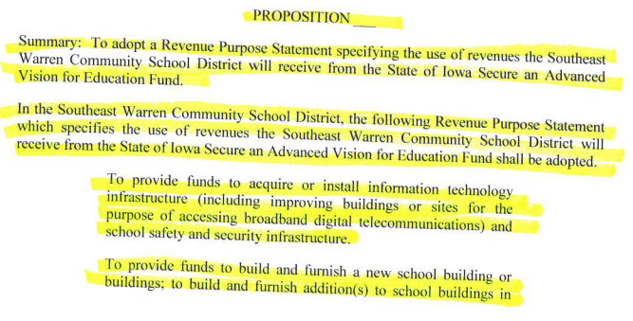

Continued on next page…
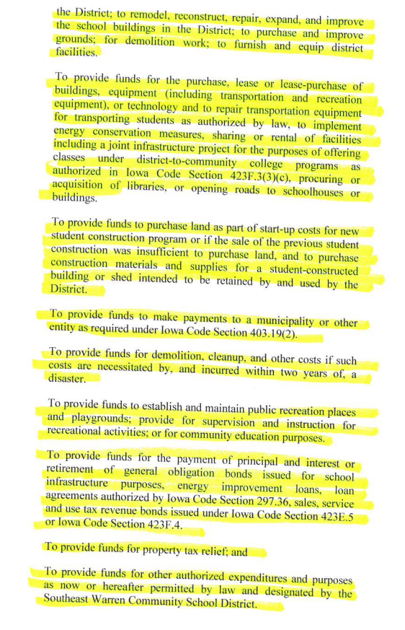
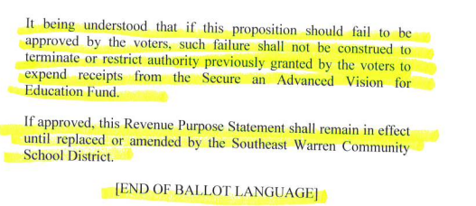

City of Cumming Public Measure VA
